[Shell Method](https://magoosh.com/hs/ap-calculus/2018/ap-calculus-review-shell-method/)

[Khan Academy Video](https://www.youtube.com/watch?v=SfWrVNyP9E8)

* Nested cylinders. Fill the shape with an infinite amount of circles the same height as itself with decreasing widths.

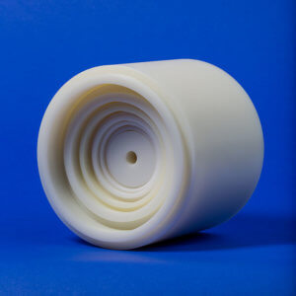

* Approximating volume :

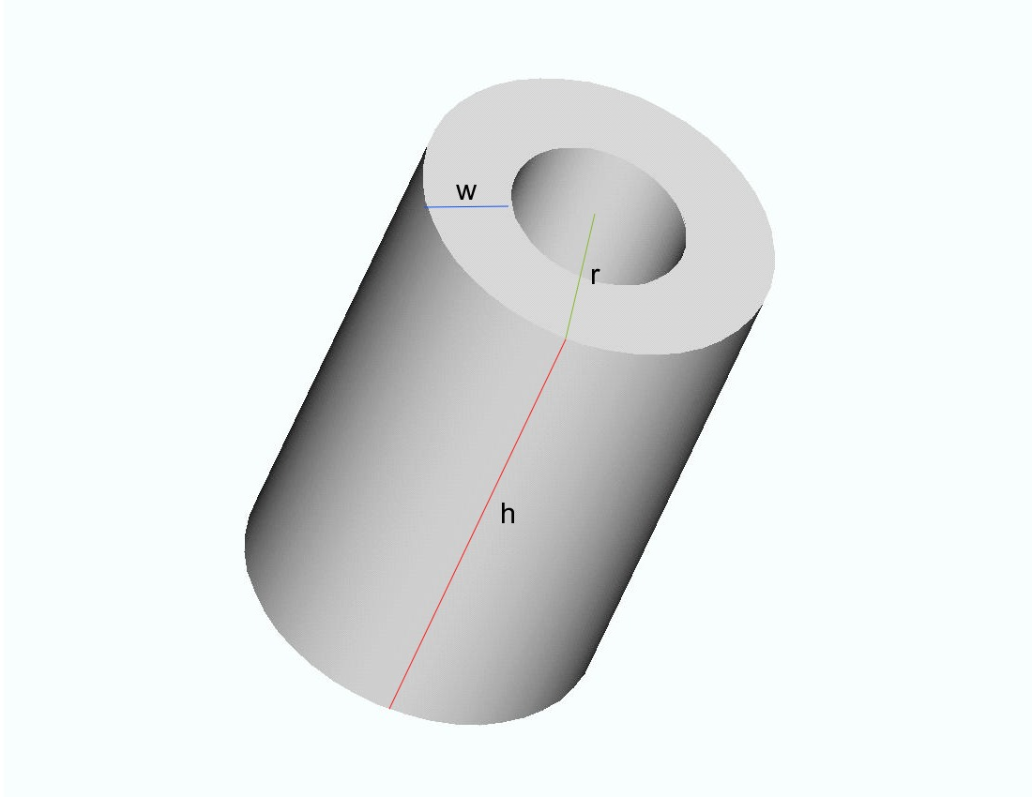

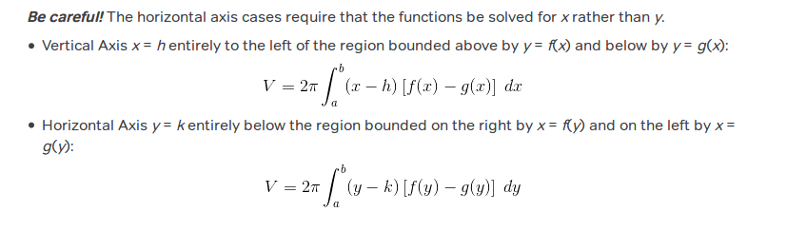

|  |  |
| --- | --- |
| Axis of Rotation | Integrate with respect to |
| Vertical : x = n | X (Everything is turned on its side compared to the previous problems, we have to make sure both boundary functions are solved for Y). **Say Y = n is the axis of rotation, solve for Y.** |
| Horizontal : y =n | Y ( Everything is turned on its side compared to the previous problems, we have to make sure both boundary functions are solved for X). **Say X = n is the axis of rotation, solve for X.** |

* This is one of the shells inserted inside the figure
* It has three components; the height, radius and thickness (width)
* *Formula : V* = 2π*rhw*
* This is only the volume of one cylinder, you need to use an integral to calculate the volume of an infinite amount of these shells.
* Breaking down the formula:
  + Easiest case is when the function is bounded between two points on the x axis
  + The radius is r = x (the distance from a typical point on the y axis)
  + The height is our function f(x)
  + The “outside” surface area of the solid is : 2Ⲡr (radius of our function)
  + dx : the width of the rectangle inside the graph